|  |  |
| --- | --- |
| Test Name | UC04 Complete Scans |
| Use Case Tested: | Complete Scans |
| Test Description: | Tests when a borrower has scanned books but not reached their limit, they can move to the Confirming Loans page. |
| Pre-conditions | The program has been started and initialised.  The “Borrow” button has been pressed.  The Borrower has swiped in and is not restricted.  The Borrower has scanned books.  The Borrower has not reached their limit. |
| Post-conditions | System shows the “Confirming Loans” panel.  The Book scanner becomes disabled.  The final “Pending Loan” list is displayed.  The Cancel button is enabled.  The Reject button is enabled. |
| Notes: |  |

|  |  |  |
| --- | --- | --- |
| Data 1 Attempt | |  |
| Result (Pass/Fail/Warning/Incomplete) | Pass | |

|  |  |  |  |  |
| --- | --- | --- | --- | --- |
|  | TEST STEP | EXPECTED TEST RESULTS | P | F |
|  | Borrower presses the “Complete” button on the “Scanning” panel. | System shows the “Confirming Loans” panel. | P |  |
|  |  | The Book scanner becomes disabled. | P |  |
|  |  | The final “Pending Loan” list is displayed. | P |  |
|  |  | The Cancel button is enabled. | P |  |
|  |  | The Reject button is enabled. | P |  |

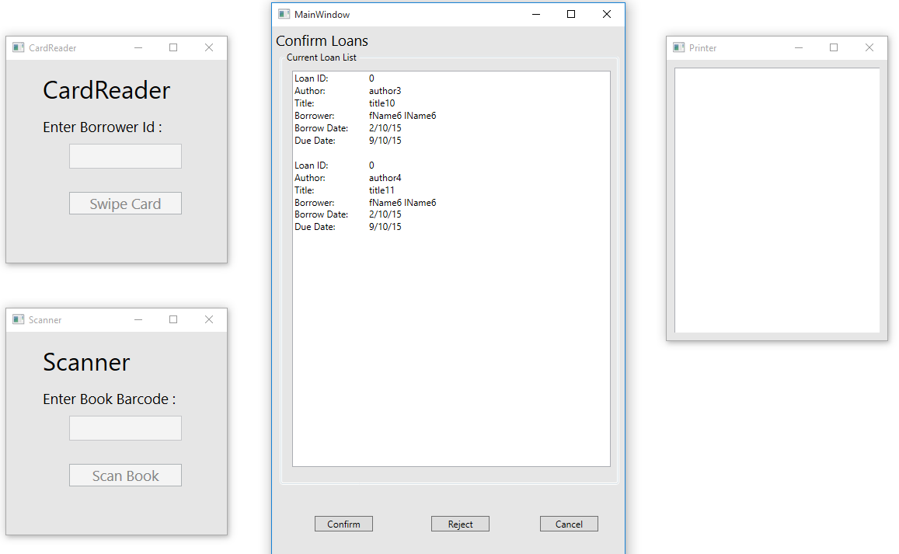

|  |  |  |  |  |  |
| --- | --- | --- | --- | --- | --- |
| Test Data Table | | | | | |
|  | **Member** | **Book** | **3** | **4** | **5** |
| Data 1 Attempt | 6 | 10 |  |  |  |
|  |  | 11 |  |  |  |